**Final Project-ETL**

CIS 9440 - Data Warehousing for Analytics

Final Project Milestone 3

Group Number - 17

Student(s) - Yan San, Tung-Ting Wang, Dongdong Song

We add the subscription to Revenue fact table as a measure and delete the member dimension.

Currently, we have four fact tables: covid_fact, rev_sub_fact, trend fact, and NFLX_Stock_Price_Fact; and two conformed dimension tables: region_dim and date_dim.

We use python to extract, transform and load the data. The following are the step description for ETL processes:

1.The following codes explain how we extract the Covid-19 data from Google public data and set the extract function named Extract_Covid_Data.

### 1a. extract COVID data

def Extract_Covid_Data():

# SQL query to run in BigQuery to extract Hacker News story data

sql_query = """

SELECT date, country_name, SUM(new_confirmed) as new_confirmed

FROM `bigquery-public-data.covid19_open_data.covid19_open_data`

WHERE new_confirmed IS NOT NULL

AND date BETWEEN '2020-01-01' AND '2021-04-19'

AND country_name IN (SELECT country_name FROM `bigquery-public-data.covid19_open_data.covid19_open_data` WHERE country_name LIKE 'United States'

or country_name LIKE 'Canada'

or country_name LIKE 'United Kingdom'

or country_name LIKE 'Ireland'

or country_name LIKE 'Denmark'

or country_name LIKE 'Finland'

or country_name LIKE 'Norway'

or country_name LIKE 'Sweden'

or country_name LIKE 'Netherlands'

or country_name LIKE 'France'

or country_name LIKE 'Germany'

or country_name LIKE 'South Africa'

or country_name LIKE 'Brazil'

or country_name LIKE 'Argentina'

or country_name LIKE 'Chile'

or country_name LIKE 'Colombia'

or country_name LIKE 'Mexico'

or country_name LIKE 'Australia'

or country_name LIKE 'New Zealand'

or country_name LIKE 'Japan'

or country_name LIKE 'India'

or country_name LIKE 'South Korea')

GROUP BY date, country_name

ORDER BY country_name , date

"""

#Those countries above are the most crucial members in their regions. Therefore, we select those countries’ names to represent the region.

# store extracted data in new dataframe

Covid_df = client.query(sql_query).to_dataframe()

# validate that >0 stories have been extracted and return dataframe

if len(Covid_df) > 0:

print(len(Covid_df), "Covid-19 data is extracted")

return Covid_df

else:

print("Extraction FAILED")

The following codes show how we clean the data which we extracted from Google public dataset.

### 1b.Clean COVID data

def Clean_Covid_Data(df):

# check if table exists in your database

try:

table_id = 'CIS_9440_project.covid_fact'

table = client.get_table(table_id)

print("Covid Fact table exists, number of rows: ", table.num_rows)

print("now filtering for only new data")

# if the table is not already in the database, clean all data

except:

print("Covid Fact table is not in database, cleaning all data")

# drop rows with null values

if df.isnull().sum()[4] > 0:

df.dropna()

print(df.isnull().sum()[4], "null values dropped")

else:

print("Covid data has no null values")

# drop duplicate values

if len(df[df.duplicated()]) > 0:

df.duplicated(keep = 'first')

print(len(df[df.duplicated()])/2.0, "duplicate values dropped")

else:

print("Covid data has no duplicate rows")

print("Covid data cleaning successful")

return df

The following codes show how we create the Covid_fact table and create a function called Create_Covid_Fact.

### 1c. Create COVID_fact

def Create_Covid_Fact(df, region_dim):

#create date_id

df['date_id'] = df['date'].apply(lambda x: x.strftime("%Y%m%d"))

# create region_id column #left -> df's column #right->region_dim's column, inner join

df = df.merge(region_dim, left_on='region_name' , right_on='region_name',

how='inner')

# drop unneeded columns

for c in ['date','region_name']:

df.drop(c, axis = 1, inplace=True)

return df

These are executing codes that are used to transfer the raw data to the normalized Covid fact table.

####.COVID related

#download covid dataset from bigquery

covid_raw = dsf.Extract_Covid_Data();

#add new column

dsf.Append_Region(covid_raw)

### Create covid fact

covid_fact = dsf.Create_Covid_Fact(covid_transformed, region_dim)

#upload the dataset to my bigquery, making it easier to manipulate

dsf.load_df_to_bigquery(covid_raw, 'covid_append_column')

#Using SQL to transform the data and downloading the dataset

covid_transformed = dsf.Transform_Country_Region()

### add region column (since we don’t have a “region” column in the “covid_raw” table.)

def Append_Region(df):

df.insert(0, 'region_name', 0)

covid_region = []

L = 'Latin America'

US = 'United States and Canada'

EMA = 'Europe, Middle East, and Africa'

AP = 'Asia-Pacific'

for name in df['country_name']:

if name == 'United States of America':

covid_region.append(US)

elif name == 'Canada':

covid_region.append(US)

elif name == 'United Kingdom' :

covid_region.append(EMA)

elif name == 'Ireland':

covid_region.append(EMA)

elif name =='Denmark':

covid_region.append(EMA)

elif name =='Finland':

covid_region.append(EMA)

elif name =='Norway':

covid_region.append(EMA)

elif name =='Sweden' :

covid_region.append(EMA)

elif name =='Netherlands':

covid_region.append(EMA)

elif name =='France':

covid_region.append(EMA)

elif name =='Germany' :

covid_region.append(EMA)

elif name == 'South Africa':

covid_region.append(EMA)

elif name == 'Argentina':

covid_region.append(L)

elif name == 'Brazil':

covid_region.append(L)

elif name == 'Chile':

covid_region.append(L)

elif name =='Colombia' :

covid_region.append(L)

elif name =='Mexico' :

covid_region.append(L)

elif name == 'Australia':

covid_region.append(AP)

elif name == 'New Zealand' :

covid_region.append(AP)

elif name == 'Japan' :

covid_region.append(AP)

elif name == 'India':

covid_region.append(AP)

elif name == 'South Korea':

covid_region.append(AP)

df['region_name'] = covid_region

### Transform the format “country” into “region” by selecting region_name and grouping by region_name

def Transform_Country_Region():

sql_query = '''

SELECT date, region_name, SUM(new_confirmed) as new_confirmed

FROM `baruch-cis.CIS_9440_project.covid_append_column`

GROUP BY date, region_name

ORDER BY region_name, date

'''

transform_df = client.query(sql_query).to_dataframe()

if len(transform_df) > 0:

print(len(transform_df), "transformation data is extracted")

return transform_df

else:

print("Transformation FAILED")

The screenshots are the Fact tables shown on the big query, including the covid_fact schema and preview.

covid schema:

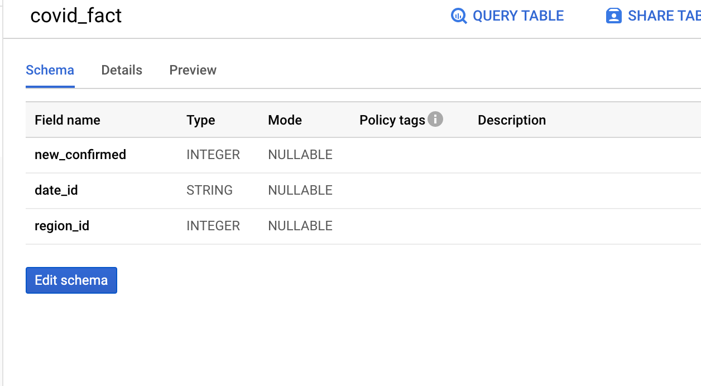

covid fact1:

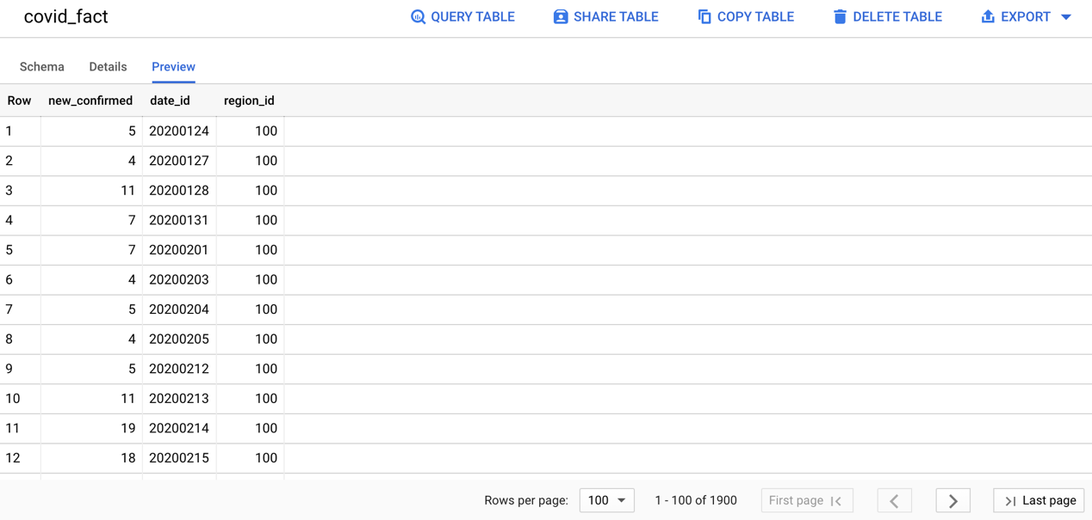

covid fact2:

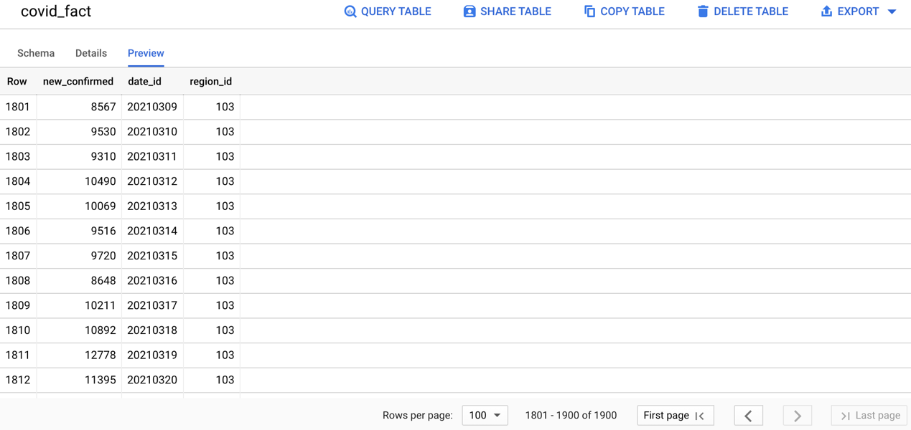

2. The following codes explain how we extract the Netflix data from its revenue and subscription file which we get from Netflix investor relations and set the extract function named Extract_rev_sub_Data.

rev_sub schema:

### 2a.extract rev_sub

def Extract_rev_sub_Data():

# SQL query to run in BigQuery to extract revenue and subscribers related data

sql_query = """

select *

from `baruch-cis.CIS_9440_project.sub_rev_2016_2020`

order by region_name;

"""

# store extracted data in new dataframe

rev_sub_df = client.query(sql_query).to_dataframe()

# validate that >0 stories have been extracted and return dataframe

if len(rev_sub_df) > 0:

print(len(rev_sub_df), "rev_sub extracted")

return rev_sub_df

else:

print("rev_sub extraction FAILED")

The following codes show how we create the ‘NFLX_rev_sub_Fact’ fact table and create a function called Create_NFLX_rev_sub_Fact.

### 2b. Create rev Fact

def Create_NFLX_rev_sub_Fact(df, region_dim):

# create date_id column

new_dateform=[] #transform string to date form

for c in df['date']:

new_dateform.append(c)

df['date'] = new_dateform

print(df['date'])

df['date_id'] = df['date'].apply(lambda x: x.strftime("%Y%m%d"))

# create region_id column #left -> df’s column #right->region_dim’s column

df = df.merge(region_dim, left_on='region_name' , right_on='region_name',

how='inner')

# drop unneeded columns

for c in ['fiscal_year', 'fiscal_qtr','date','region_name']:

df.drop(c, axis = 1, inplace=True)

return df

These are executing codes which we used to extract data and transfer the raw data to the normalized ‘NFLX_rev_sub_Fact’ fact table and then load it into the big query.

####. extract sub_rev

rev_sub = dsf.Extract_rev_sub_Data()

###.Create rev_sub fact

rev_sub_fact = dsf.Create_NFLX_rev_sub_Fact(rev_sub, region_dim)

dsf.load_df_to_bigquery(df= rev_sub_fact, table_name= 'rev_sub_fact')

The screenshots are the Fact tables shown on the big query, including the Rev_sub_fact schema and preview.

Rev_sub_fact schema

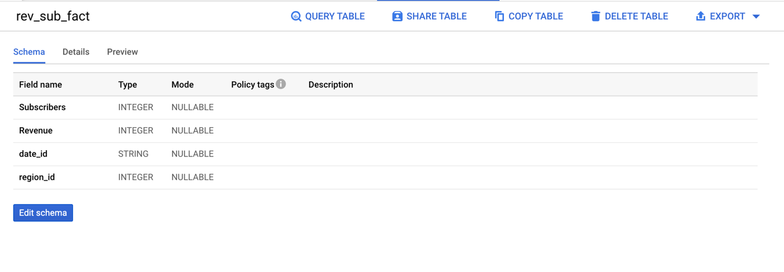

rev_sub fact1:

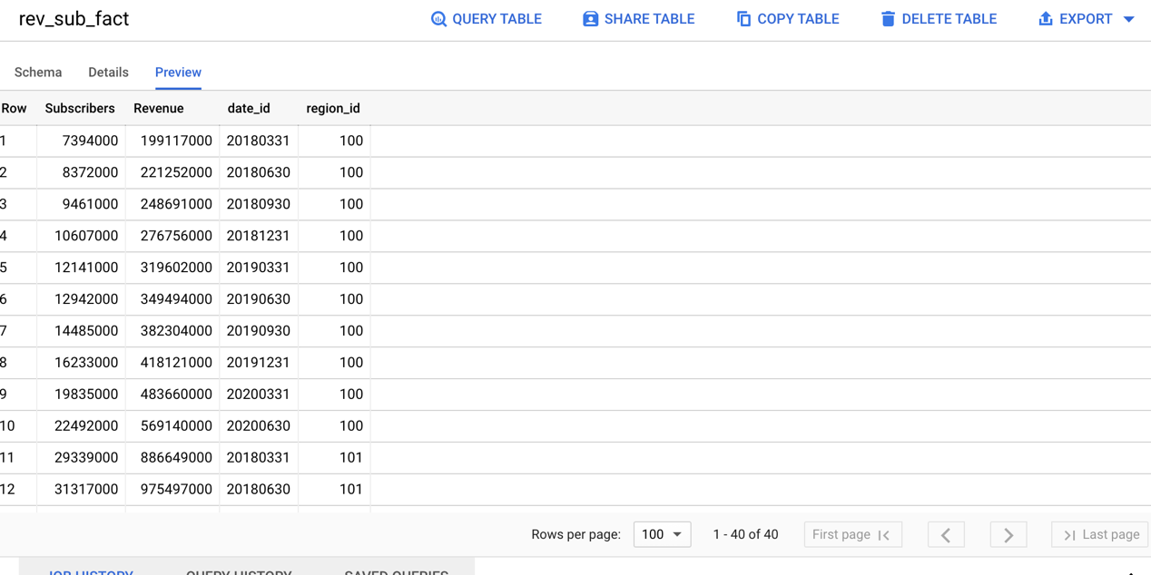

rev_sub fact2:

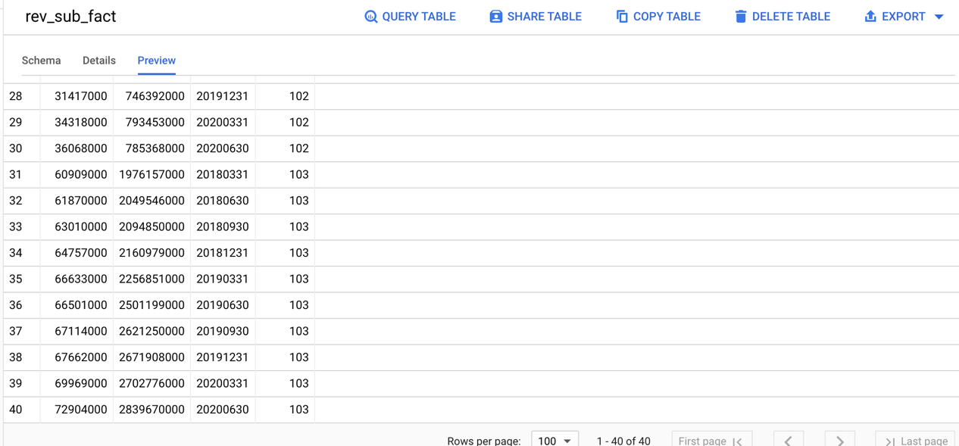

3. The following codes explain how we extract the Netflix trend data from Google trends ( we download the trend data manually and save them as CSV files in local devices) . Then we set the extract function named Extract_Trend_Data.

###3a.extract trend data

def Extract_Trend_Data():

# SQL query to run in BigQuery to extract Hacker News story data

sql_query = """

SELECT Date, region, avg(netflix_Trend) as popularity

FROM `baruch-cis.CIS_9440_project.trend_5years`

GROUP BY Date, region

ORDER BY region, Date;

"""

# store extracted data in new dataframe

Google_trend_df = client.query(sql_query).to_dataframe()

# validate that >0 stories have been extracted and return dataframe

if len(Google_trend_df) > 0:

print(len(Google_trend_df), "trend extracted")

return Google_trend_df

else:

print("trend extraction FAILED")

The following code show the how we make trend_Fact table and create a function called Create_trend_Fact

###3b.create trend fact

def Create_trend_Fact(df, region_dim):

# create date_id column

new_dateform=[] #transform string to date frame

for c in df['Date']:

new_dateform.append(c)

df['Date'] = new_dateform

print(df['Date'])

df['date_id'] = df['Date'].apply(lambda x: x.strftime("%Y%m%d"))

# create region_id column #left -> df's column #right->region_dim's column！

df = df.merge(region_dim, left_on='region' , right_on='region_name',

how='inner')

# drop unneeded columns

for c in ['Date','region']:

df.drop(c, axis = 1, inplace=True)

return df

These are executing codes which we used to extract data and transfer the raw data to the normalized trend_fact fact table and then load to the big query.

###. extract trend data

trend_region = dsf.Extract_Trend_Data()

###. create trend fact

trend_fact = dsf.Create_trend_Fact(trend_region, region_dim)

## load to big query

dsf.load_df_to_bigquery(df= trend_fact, table_name= 'trend_fact')

The screenshots are the Fact tables shown on the big query, including the trend_fact schema and preview.

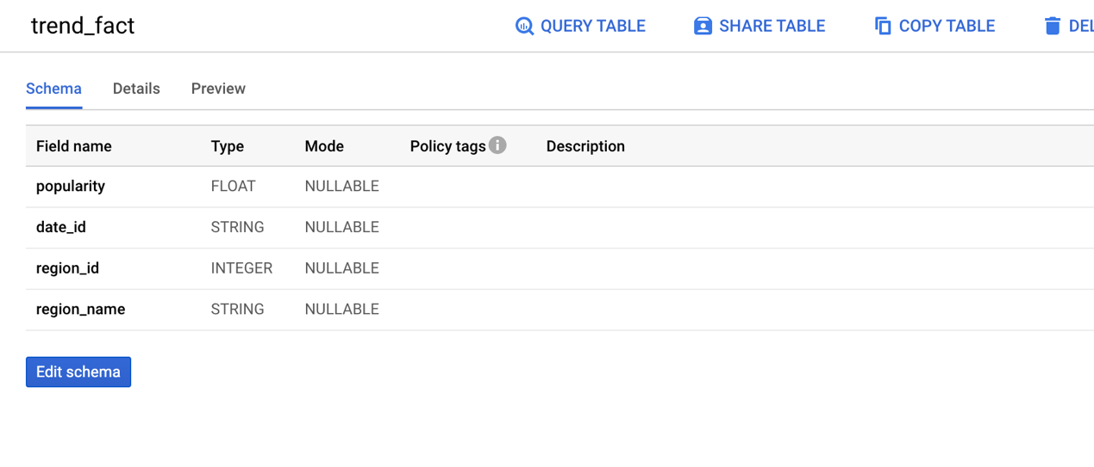

Trend fact1:

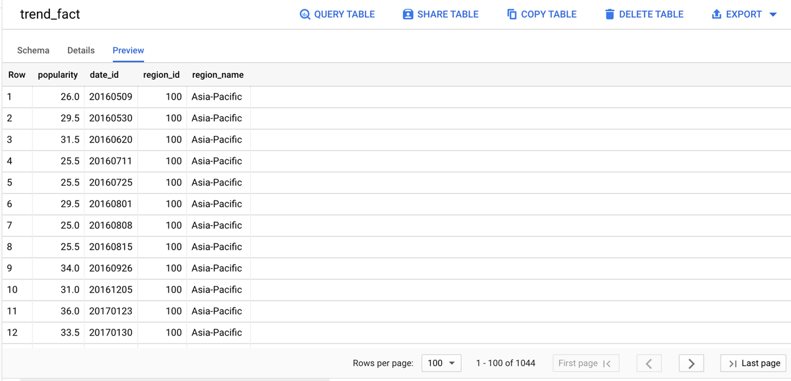

Trend fact 2 :

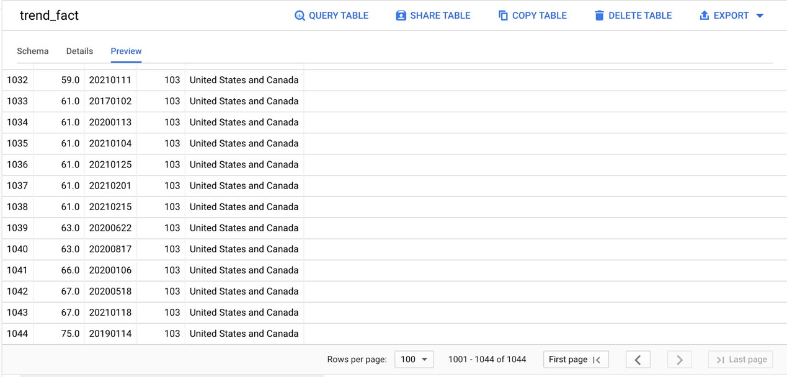

4. For this part, we use the yfinance package to export the Netflix stock price from yahoo finance from 2016 to 2021 and transfer the date to date_id and extract the date_id and Adj Close and save at the local.

### 4 Create stock fact

import pandas as pd

import numpy as np

import pandas_datareader as web

import datetime

try:

import yfinance as yf

except:

print("installation unsuccessful")

def create_stock_df(stock, start, end):

# get the data from yahoo finance

df = yf.download(stock,

start=start,

end=end,

progress=False)

# add extra columns for day, stock title,

# simple moving average, and closing price average difference

df['day'] = range(1, len(df) + 1)

df['stock'] = stock

df = df.reset_index()

return df

netflix_2016_df = create_stock_df("NFLX",

start = '2016-01-01',

end = '2021-04-23')

df= pd.DataFrame(netflix_2016_df)

df['date_id'] = df['Date'].apply(lambda x: x.strftime("%Y%m%d"))

df2 = df[["date_id", "Adj Close"]]

df2

df2.to_csv(r'C:\Users\Jeff Song\OneDrive\Desktop\Spring 2021 Course\CIS 9440 Data Warehousing\finalproject\NFLX_Stock_Price_Fact.csv', index=False)

Then we upload the csv file Netflix_stock_price_fact to big query manually and order the date by asc.

Stock Schema

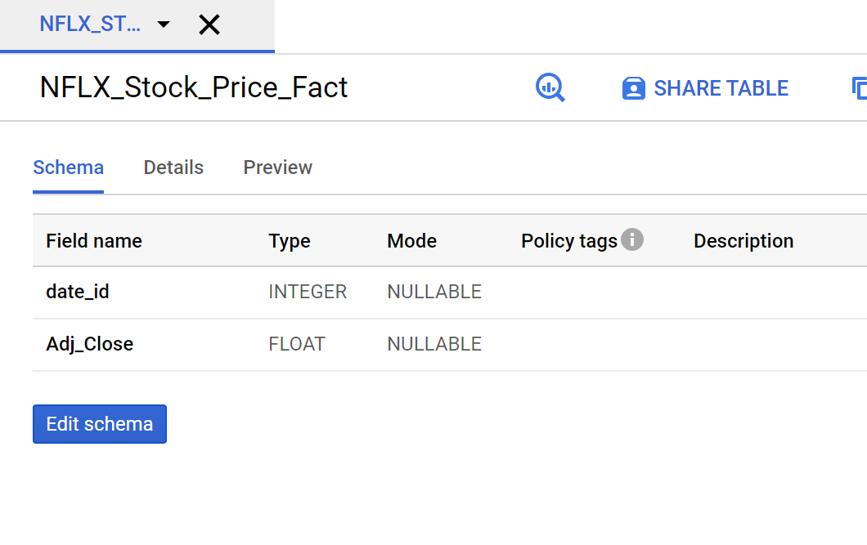

Stock fact:

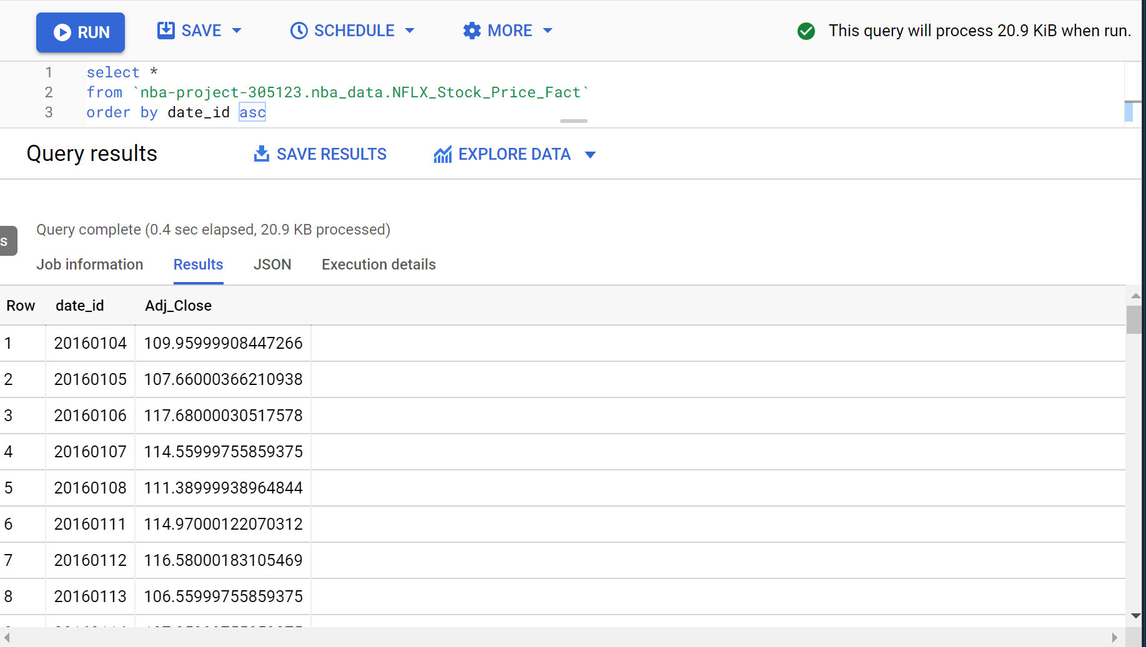

5. For this part we create the date dimension to match the date in fact tables up load to big query.

### 5.create date dimension

def create_date_dimension():

sql_query = """

SELECT

CONCAT (FORMAT_DATE("%Y",d),FORMAT_DATE("%m",d),FORMAT_DATE("%d",d)) as date_id,

d AS full_date,

EXTRACT(YEAR FROM d) AS year,

EXTRACT(WEEK FROM d) AS year_week,

EXTRACT(DAY FROM d) AS year_day,

EXTRACT(YEAR FROM d) AS fiscal_year,

FORMAT_DATE('%Q', d) as fiscal_qtr,

EXTRACT(MONTH FROM d) AS month,

FORMAT_DATE('%B', d) as month_name,

FORMAT_DATE('%w', d) AS week_day,

FORMAT_DATE('%A', d) AS day_name,

FROM (

SELECT

*

FROM

UNNEST(GENERATE_DATE_ARRAY('2016-01-01', '2021-05-01', INTERVAL 1 DAY)) AS d )

"""

# store extracted data in new dataframe

date_df = client.query(sql_query).to_dataframe()

# validate that >0 stories have been extracted and return dataframe

if len(date_df) > 0:

print("date dimension created")

return date_df

else:

print("date dimension FAILED")

These are executing codes for creating the date dimension to big query

###5. create date_dim

date_dim = dsf.create_date_dimension()

dsf.load_df_to_bigquery(df= date_dim, table_name= 'date_dim')

The screenshots are the Fact tables shown on the big query, including the date_dim schema and preview.

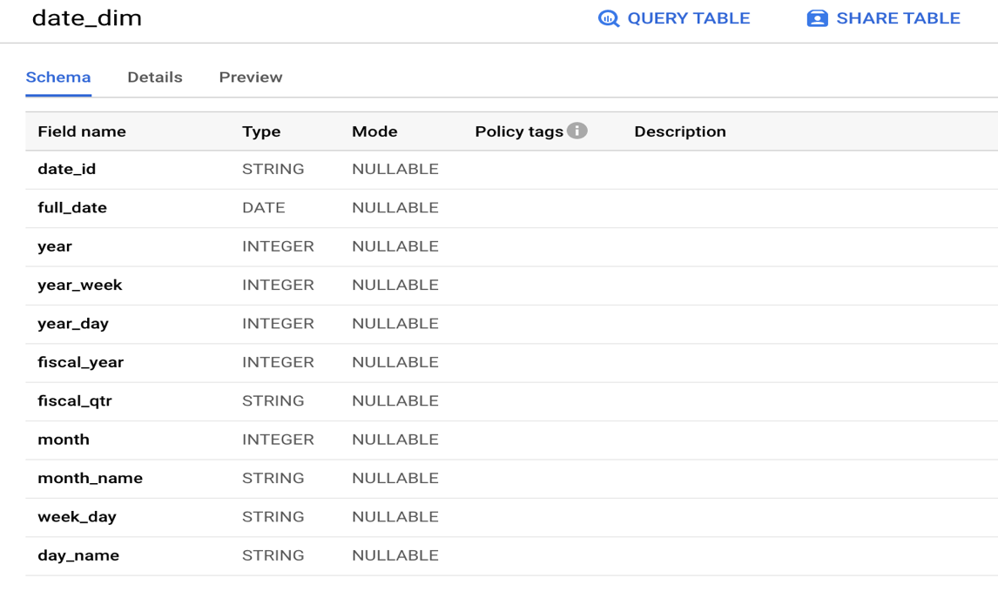

Date dim 1:

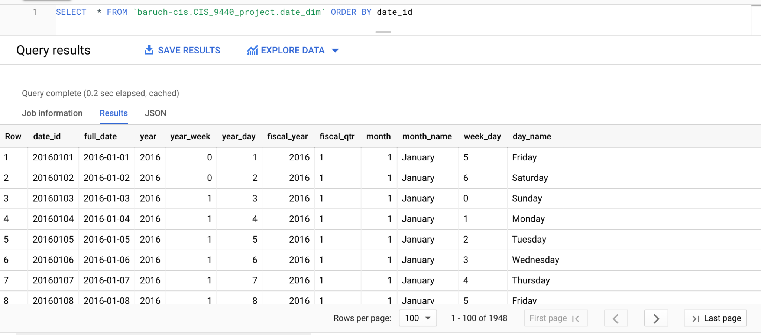

Date dim 2:

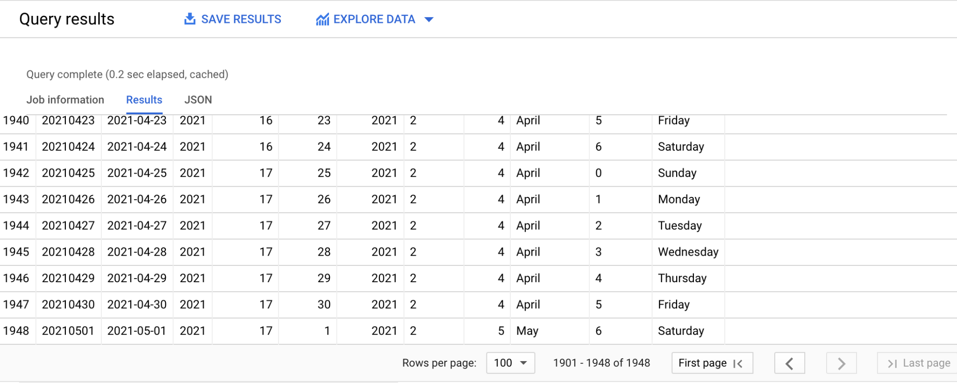

6. The following codes are about region dim, since in real situations, the dataset Popularity trend and Covid 19 are only recorded by country, however, Netflix's revenue and subscription are documented by region. We have to make a function to transfer the country to the region in which they belong and set the region as a dimension table.

Follow the format of Netflix’s revenue and subscription dataset. We put the countries into four groups: Latin America, United and Canada; Europe, Middle East, and Africa; and Asia-Pacific.

The steps are shown as follow:

### add region column

def Append_Region(df):

df.insert(0, 'region_name', 0)

covid_region = []

L = 'Latin America'

US = 'United States and Canada'

EMA = 'Europe, Middle East, and Africa'

AP = 'Asia-Pacific'

for name in df['country_name']:

if name == 'United States of America':

covid_region.append(US)

elif name == 'Canada':

covid_region.append(US)

elif name == 'United Kingdom' :

covid_region.append(EMA)

elif name == 'Ireland':

covid_region.append(EMA)

elif name =='Denmark':

covid_region.append(EMA)

elif name =='Finland':

covid_region.append(EMA)

elif name =='Norway':

covid_region.append(EMA)

elif name =='Sweden' :

covid_region.append(EMA)

elif name =='Netherlands':

covid_region.append(EMA)

elif name =='France':

covid_region.append(EMA)

elif name =='Germany' :

covid_region.append(EMA)

elif name == 'South Africa':

covid_region.append(EMA)

elif name == 'Argentina':

covid_region.append(L)

elif name == 'Brazil':

covid_region.append(L)

elif name == 'Chile':

covid_region.append(L)

elif name =='Colombia' :

covid_region.append(L)

elif name =='Mexico' :

covid_region.append(L)

elif name == 'Australia':

covid_region.append(AP)

elif name == 'New Zealand' :

covid_region.append(AP)

elif name == 'Japan' :

covid_region.append(AP)

elif name == 'India':

covid_region.append(AP)

elif name == 'Korea':

covid_region.append(AP)

df['region_name'] = covid_region

### Transform country into region

def Transform_Country_Region():

sql_query = '''

SELECT date, region_name, SUM(new_confirmed) as new_confirmed

FROM `baruch-cis.CIS_9440_project.covid_append_column`

GROUP BY date, region_name

ORDER BY region_name, date

'''

transform_df = client.query(sql_query).to_dataframe()

if len(transform_df) > 0:

print(len(transform_df), "transformation data is extracted")

return transform_df

else:

print("Transformation FAILED")

Establish create_region_dimension function.

###6. Create_region_dimension

def create_region_dimension(covid_df):

unique_region = covid_df['region_name'].unique().tolist()

# create blank list of dimension rows

dimension_rows = []

# create author dimension with a surrogate key

for region_id, region_name in enumerate(unique_region, start = 100):

temp_list = [region_id, region_name]

dimension_rows.append(temp_list)

region_dim = pd.DataFrame(data=dimension_rows,

columns = ['region_id', 'region_name'])

print("region dimension create")

print(dimension_rows)

return region_dim

Create region_dim and upload the table to big query.

###6. Create_region_dimension and upload to big query

region_dim = dsf.create_region_dimension(covid_transformed)

dsf.load_df_to_bigquery(df= region_dim, table_name= 'region_dim')

The following show the schema and data preview of region_dim.

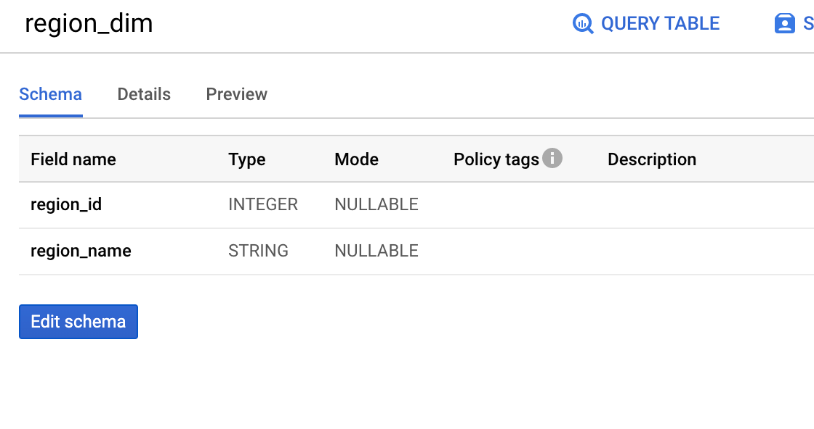

Region dim:

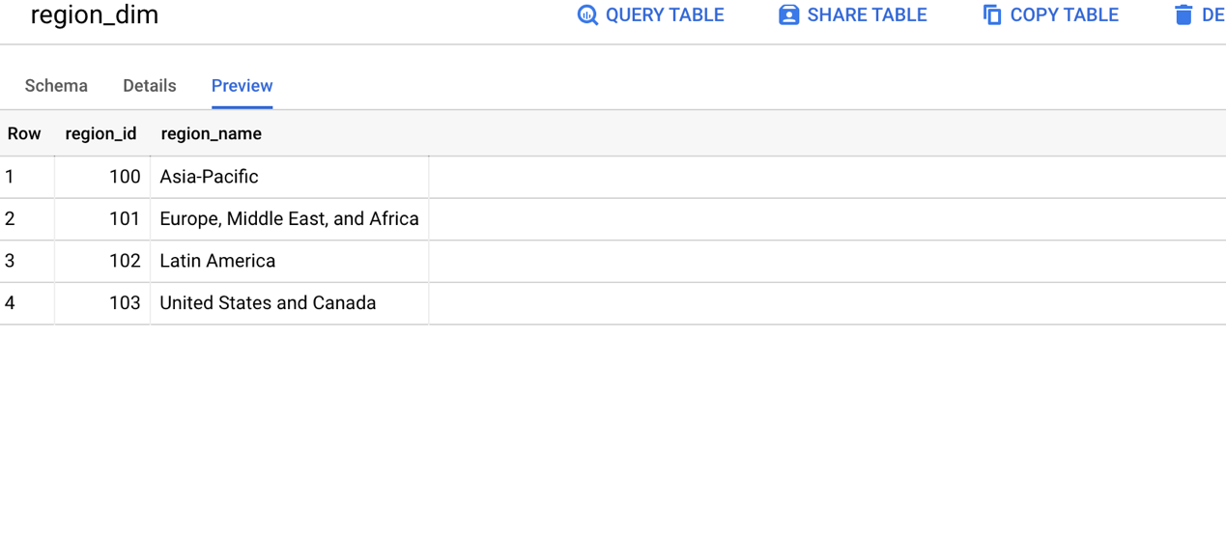

**Other Functions**

The function of loading the table to big query.

###.Load dim/fact to bigquery

def load_df_to_bigquery(df, table_name):

dataset_id = '`baruch-cis.CIS_9440_project'

dataset_ref = client.dataset(dataset_id)

job_config = bigquery.LoadJobConfig()

job_config.autodetect = True

job_config.write_disposition = "WRITE_TRUNCATE"

upload_table_name = 'CIS_9440_project.'+str(table_name)

load_job = client.load_table_from_dataframe(df, upload_table_name,

job_config=job_config)

print("Starting job {}".format(load_job))

We also export the tables to local.

#Export File

date_dim.to_excel(r'/Users/appleuser/Desktop/W4 Data Warehousing and Analytics9440/Final Project/milestone3-ETL\date_dim.xlsx', index = False)

covid_fact.to_excel(r'/Users/appleuser/Desktop/W4 Data Warehousing and Analytics9440/Final Project/milestone3-ETL\covid_fact.xlsx', index = False)

region_dim.to_excel(r'/Users/appleuser/Desktop/W4 Data Warehousing and Analytics9440/Final Project/milestone3-ETL\region_dim.xlsx', index = False)

rev_fact.to_excel(r'/Users/appleuser/Desktop/W4 Data Warehousing and Analytics9440/Final Project/milestone3-ETL\rev_fact.xlsx', index = False)

Another way to approach stock price data extraction and transformation.

def create_stock_df(stock, start, end):

# get the data from yahoo finance

df = yf.download(stock,

start=start,

end=end,

progress=False)

# add extra columns for day, stock title,

# simple moving average, and closing price average difference

df['day'] = range(1, len(df) + 1)

df['stock'] = stock

df = df.reset_index()

return df

netflix_2016_df = create_stock_df("NFLX",

start = '2016-01-01',

end = '2021-04-23')

netflix_2016_df

netflix_2016_df.to_csv(r'C:\Users\Colin\Desktop\stock.csv')#___

def extract_stock_data():

# SQL query to run in BigQuery to extract stock data

sql_query = """

select date, adj_close

from ___

order by date;

"""

# store extracted data in new dataframe

stock_df = client.query(sql_query).to_dataframe()

# validate that >0 stories have been extracted and return dataframe

if len(stock_df) > 0:

print(len(stock_df), "stock extracted")

return stock_df

else:

print("stock extraction FAILED")

Executing code to load fact/dim to big query.

###.load fact/dim to bigquery

dsf.load_df_to_bigquery(df= covid_fact, table_name= 'covid_fact')

dsf.load_df_to_bigquery(df= rev_sub_fact, table_name= 'rev_sub_fact')

dsf.load_df_to_bigquery(df= stock_fact, table_name= 'stock_fact')

dsf.load_df_to_bigquery(df= trend_fact, table_name= 'trend_fact')

dsf.load_df_to_bigquery(df= date_dim, table_name= 'date_dim')

dsf.load_df_to_bigquery(df= region_dim, table_name= 'region_dim')